AAI-500 STUDENT HELP SHEET (created by students like you!)
1 - Ethical usage of AI-generated tools, such as ChatGPT, Gemini, and Copilot, for coursework and assignments.
As you progress through the course, you may find it helpful to use ChatGPT or other LLMs to better understand the material. This is perfectly acceptable. However, it is important that you leverage these tools to help you learn the material rather than to solve the assignment problems in your stead. Here are the four LLM usage scenarios to consider:
- Using ChatGPT to aid your understanding of course materials while ensuring you are learning the concepts rather than simply copying solutions: ALWAYS OK.
- Using ChatGPT to copy/paste solutions to the Assignments without solving them yourself and not referencing your use of ChatGPT to do so: NEVER OK.
- Referencing ChatGPT usage in your assignments while copying/pasting large sections of reasoning or “general” code without understanding them (example below): NEVER OK.
  - Example:
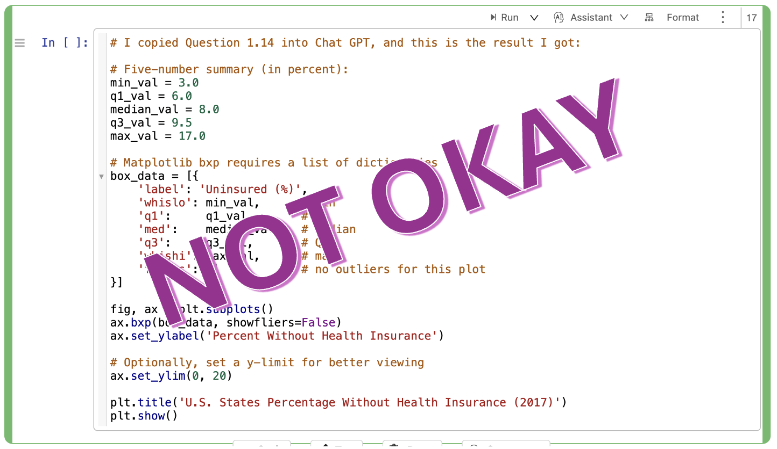
- Making limited use of ChatGPT in your assignments to identify concise elements that you could also find with a good search, such as a specific Python function, and make sure ChatGPT’s contribution is explicitly explained in your assignment: CAN BE OK
  - Example:
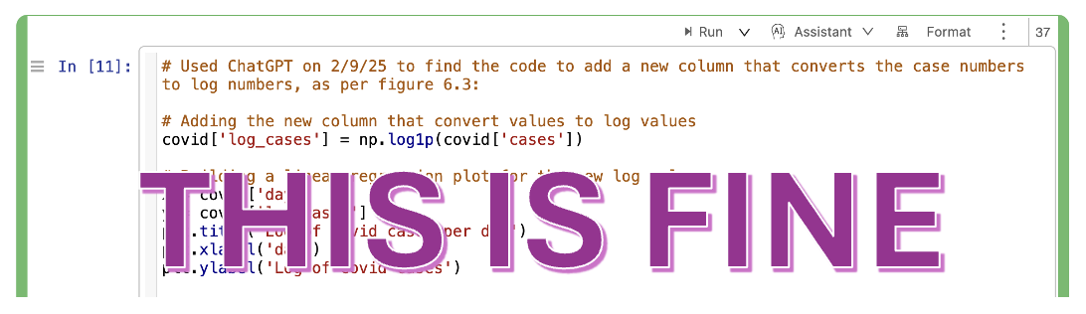
- The ChatGPT contribution is explicitly called out and dated.
- The ChatGPT contribution is limited to a very specific line that could be found by Google search.
- All of the reasoning and logic to solve the assignment was done by the student, not the LLM.
Note: There are several scenarios that would fall somewhere between the two examples with screenshots above. To navigate that grey space, use as little LLM as you can in your assignments, and always explicitly call out when it is used and explain how it helped you. Following that guideline will ensure your usage level is acceptable and ethically identified.
At the end of the day, you should always strive to ensure that you use comments to explain how the LLM helped you understand the concepts and how that propelled you toward your own work. Include your own original work to round out that explanation. If you don’t understand the concept well enough to round out an answer with your own original work, you are not ready to submit. Continue to learn, continue to grow, and come back with the knowledge required to offer your own understanding of the solution. If you can do that, your use of any LLM will be within the acceptable bounds of the program so long as you cite its use.

2 - The program focuses on applications; the book feels heavy on theory.
The textbook can seem overwhelming, especially for those without a strong mathematical background. However, if you look through the section headers, you will notice a pattern that consists of new topics and real-world examples. Being that this is a program emphasizing application, the examples are going to be the real meat of the book for this program. I recommend that you skim each new concept and then really dive into each example, referencing back to the theory shown in the concept section as you gain a deeper understanding of how the example works and what you need to do to obtain similar results. Something else you should be referencing is the Python Appendix. The main portion of the book is written in R. However, this program does not use R; it uses Python. Therefore, you should be looking at, reading, and writing Python. While appendix B offers a Python version of much of the code shown throughout the book, it does not fully cover every concept. Fortunately, the author also provides an online appendix, located at https://stat4ds.rwth-aachen.de/pdf/DS_Python_webAppendix.pdf, that rounds out anything omitted in the hard copy’s appendix. Further, the online appendix gives more robust examples of Python code for each section and does not truncate output, thus giving a more holistic view of how Python can be used to solve the presented problems.
Focus on your ability to code out the solutions. That’s the most important thing! Review the theory as part of solving the exercises, and make sure you can follow every example section. In doing so, you will absorb the theory as well. More importantly, you will have built up the required coding (Python) skills to progress through the program.
Note: Having the book in a digital format will save you considerable time on the coding assignments. With a digital format, you will be able to copy/paste Python code snippets as opposed to manually copying the snippets over by hand while glancing back and forth between your book and the screen. Furthermore, the digital format will likely support the use of ctrl+F, allowing you to quickly search a specific topic rather than having to flip through the book pages for a single keyword.
3 - Some modules can feel overwhelming.
If a specific detail is challenging, focus on the broader concepts first. Use external resources (e.g., YouTube, LLMs, discussions) to reinforce your understanding. Otherwise, simply move on with the intention of circling back to the specifics of a certain problem after you have a larger view of the coursework. Whatever your strategy, just make sure you don’t spend such a disproportionate amount of time stuck on a single concept/problem/issue that you end up behind, forcing yourself into a situation whereby you are chasing the curve trying to catch back up.
Module/week one is a soft intro to the course. It should feel relatively simple. However, it is important not to allow this to lure you into a false sense that the course will be simple. To the very stark contrast, Module 2 is, to most, the most difficult module of the course. It can feel soul-crushing, especially when compared to Module 1. It can make you wonder how much harder each module is going to get moving forward. Do not allow this fear to keep you from pressing forward. Module 2 is so difficult because it is the foundation. Spend time understanding the concepts, but don’t get sucked in so far that you become overwhelmed. If you have a general understanding, you can always circle back and deepen your understanding as you progress forward.
4 - Leverage all forms of learning.
For those who have a hard time reading large chunks of the textbook, putting chapters into tools like NotebookLM can provide an easier first approach to the material and provide the broader strokes context that will then make reading the details easier.
This hint applies to domestic online students: The Slack TA_AI bot is also useful. Make sure you tell it your course (AAI_500) as the first part of asking your question (prompt). Avoid offering what you think might be correct, as it tends to echo the solution you proposed back to you, even if it isn’t correct. Instead, ask questions about the concept of the problem. I have found that the best question to ask is simply, “What’s the best way to get started on this particular problem?” This will often return all the pertinent concepts you will need to be familiar with to solve the problem. From there, you can dive into more specific aspects of each concept as needed.
5 - Keep a copy of all previous exercises.
They will come in handy when addressing problems in future modules. Further, the same datasets are used throughout the course but are only given in detail in module 1. If you don’t have a copy, you can also find what you need in the exercises portion of Chapter One in the book.
PAY SPECIAL ATTENTION:
Book instructions for exercise 1.2 contains the keys to interpreting the ‘Students’ file for:
- Belief in life after death (for 4.4)
- Gender (for 4.14).
6 - Start early and ensure you have a solid environment.
A lot of time can be needed to get your environment properly set up. One of the biggest issues students struggle with is converting their notebooks into .PDF format. It is best to set up your environment to be able to handle this conversion. However, if you find that you cannot do so, or that you waited too long to get started and need a quick one-off way to convert, there are online resources. https://www.vertopal.com/ is one such resource. Always open and review the file after conversion. Make sure all your data appears as expected, none of your code has been cut off, and that your text is formatted properly. If it is not, edit your notebook, convert the edited notebook to PDF, and review it again.
Note: In the prep materials for the class, Cocal is mentioned as a viable Jupyter Notebook platform you can use. If you are struggling with setting up your environment or exporting to .PDF, Cocal has that functionality built-in and can free up your time to focus on the class materials.
7 - Start with a focus on your final project.
This one likely seems difficult to do. After all, you won’t even be introduced to the final project until the second module. However, you have the ability to look ahead in the modules. Start the course by looking over the expectations for the final project and try to picture what specific skills you will need to learn to accomplish the project. For this course, the final project requires you to use a dataset to make a prediction. Therefore, you will need to learn how to distinguish what distributions best match your data as predictions based on improper distributions will produce inaccurate results. Distribution recognition is a key skill that will follow you throughout the program. Further, it is one that you can miss if you are just skimming through the material and focusing on the exercises. Most often, the proper distribution is given as part of the exercise, meaning you get little practice deciphering for yourself until the final project is upon you.
Final Project Tip: Find a dataset that actually interests you, not just one that is simple or very complicated. You will spend a good amount of time on it, and trying to solve a question that you find interesting will help those hours go by more enjoyably and build up your resume.
8 - Work on things outside of the class as well.
Join kaggle.com or some similar community. Compete in AI / ML competitions. Focus on being able to solve problems rather than doing well in the competition. You are a student. It is perfectly acceptable to do poorly in these competitions. However, getting started now will help solidify your understanding as you progress through this graduate program.
9 - Check your assignment PDF before submitting it.
Formatting often gets messed up during export. Before submitting your answers, open and read the full PDF you just exported before uploading it to be graded. You’ll often find that code and graphs that looked great in your notebook have been clipped or truncated in your PDF. That’s a problem you can easily fix, but only if you see that it needs to be fixed!
10 - Each Module contains a “Module [x] Readings” in which you will find a link to all required datasets.
Assignments will frequently say, “In the ‘Students’ file, do XYZ” without specifying where to find that file. All necessary files have a link in the Required Readings page for each module, and it’s always the same link. It would be wise to bookmark this page for use throughout the course. The dataset breakdown can often be found in the Chapter 1 exercises should you need assistance deciphering the meaning of specific values within a dataset.
11 - Quiz verbiage is very precise.
The Quizzes are not easy, and their verbiage is quite specific - a small difference in wording can make an otherwise true statement untrue. Pay very close attention to each word throughout the quiz questions, and do not rush.
12 - GitHub
GitHub use is required for your Group Project. Initial GitHub setup, and especially authentication, can be very tricky if this is your first time using it. Create an account and practice making pull requests early so that you’re not struggling to figure it out just as your project is due.
13 - Other Notes
As you progress through the course, it will be helpful to create your own dictionary/notes to keep track of the concepts and terms you have learned. The same is true of Python tools that you will use in the labs and assignments, which will come in handy again later. It may be helpful to create a dedicated Jupyter notebook in which you can store these tools and notations for future use and reference.
14 - Checking Assignments Before Submission
- Actionable:
  - Create a submission checklist:
    - Are graphs truncated?
    - Are all outputs visible?
    - Does the formatting look correct?

15 - Use Slack (respectfully!) This hint applies to domestic online students.
Slack is a great space to ask questions. However, it is important to ask good questions that include relevant details rather than trying to use the collective Slack community as a personal debugging engine for issues you are having.
Examples questions:
- Does anyone know of a better way to drill down into a nested numpy.ndarray?
My call is something like ret = some_function() and is returning something like [[“some_value”]] I want to grab that value in an f-string.
Because it is a numerical value, my first thought was print(f “value: {float(ret):.2f}”)
This works, but I get a DeprecationWarning:
My unattractive solution is print(f"value: {ret.flatten()[0]:.2f}")
It works... and I’ll use it if need be, but I figured I’d post and see if anyone has a more elegant solution.
This is a good question. It is asking for something very specific and it shows what solutions have already been tried. You can also share the screenshots of errors to support your questions.

- Can someone please help me with the homework?
This is not a good question. It places an onus of work on the people helping and requires helpers to ask further questions to drill down to what the poster actually needs. Please be considerate of your classmates and make yourself as easy to help as possible.

- Hello everyone, I have a question regarding Q#6.8, part (b). I believe I understand the question, the correlation is 0.79 with aggregated data, but it might decrease when considering individual-level data, illustrating an ecological fallacy.
My question is: Are we supposed to create hypothetical data to demonstrate a lower correlation? If so, how can we do that?
This is a great question. It clearly identifies what problem is being worked on. The poster demonstrates his or her understanding of the problem as well as the potential solution before asking about tactics to solve the problem.

- What’s the password to use to watch the recorded video (Office Hours)? (when it was already posted).
This is a bad question and will likely lead to frustration among your classmates. Please read through previous posts before asking questions.

In Slack, students can confer with one another, sharing thoughts and potential strategies for solutions. The professors will jump in if the ideas are going in the wrong direction. It is a wonderful space to be able to add to your understanding. However, posting questions that have already been answered, or are actively being debated, is impolite. If you are going to interact on Slack (as you should) develop a habit of checking it each day. Read through what has been discussed. Even if you never post, the information gained by reading through the posts of others will be valuable. Staying informed will help you be a better team player overall.
Slack tip: You can use the Search functionality to see if the assignment question you’re struggling with has been discussed earlier in the thread. If you don’t find the answer you need, ASK! The other students will have valuable insights to share.

